Software Requirements Specification (SRS)

Project Name: Conference Management System (CMS)
Module: Editorial Screening & Reviewer Assignment
Client: Faculty of Graduate Studies
Technology Stack: Google Apps Script (Web App), Google Drive (Database/File Storage)
1. Introduction
1.1 Purpose
The purpose of this document is to define the functional and non-functional requirements for the Editorial Screening and Reviewer Assignment modules of the Conference Management System (CMS).
1.2 Scope
The scope of this document includes:
● Editorial Formatting Check: Initial screening of submissions and managing the correction/resubmission loop.
● Originality Verification: Routing papers to Track Editors and Chief Editors for plagiarism and content checks.
● Reviewer Management: Selection of reviewers by the Chief Editors and Editorial Manager, and an automated invitation process.
● Decision Automation: Automated rejection or acceptance notifications based on Editorial and Originality checks.

2. Functional Requirements
2.1 Editorial Screening Module (FR-04)
This module manages the initial formatting check and resubmission process performed by the Editorial Manager.
- FR-04.01: The system shall display a list of "Pending Submissions" to the Editorial Manager for formatting verification.
- FR-04.02: The Editorial Manager shall be able to view the submitted manuscript and Title Page to verify adherence to formatting guidelines.
- FR-04.03: The system shall provide the Editorial Manager with options to mark the submission as "Format Correct" or "Format Incorrect".
- The system shall allow the Editorial Manager to update the formatting status of a submission to either "Approved" or "Rejected due to Formatting."
- FR-04.04: If "Format Incorrect" is selected, the system shall require the Editorial Manager to input feedback comments regarding the errors.
- FR-04.05: Upon submitting the feedback, the system shall automatically:
- Send an email to the Corresponding Author with the formatting instructions.
- Unlock the submission to allow the author to upload the corrected version.
- Update the submission status to "Awaiting Correction".
- FR-04.06: The system shall allow the Corresponding Author to edit and resubmit the paper only if the status is "Awaiting Correction".
- FR-04.07: Upon resubmission, the system shall notify the Editorial Manager to perform a second formatting check.
- FR-04.08: If the Editorial Manager marks the paper as "Format Incorrect" for the second time (Resubmission Failure):
- The system shall automatically change the status to "Rejected".
- The system shall send a rejection notification to the Corresponding Author.
- The system shall terminate the process for that specific paper ID.
- FR-04.09: If the formatting is marked as "Format Correct", the system shall forward the paper to the next stage (Originality Check).

2.2 Originality Check & Routing Module (FR-05)
This module handles the verification of content originality by Track Editors and Chief Editors.
- FR-05.01: The system shall allow the Editorial Manager to route format-approved papers to the relevant Track Editors and Chief Editors.
- FR-05.02: The system shall notify the assigned Track Editors and Chief Editors via email.
- FR-05.03: The Track Editors shall be able to check the paper and mark the originality as "Approved" or "Rejected".
- FR-05.04: The Chief Editors shall be able to check the paper and mark the originality as "Approved" or "Rejected".
- FR-05.05: If either the Track Editor or Chief Editor selects "Rejected":
- The system shall update the paper status to "Rejected".
- The system shall notify the Editorial Manager.
- The process shall stop immediately.
- FR-05.06: If the Chief Editor approves the originality, the system shall require the Chief Editor to input names/details of "Suggested Reviewers".
- FR-05.07: If the Track Editor approves the originality, the system shall require the Editorial Manager to input names/details of "Suggested Reviewers".

2.3 Reviewer Invitation Module (FR-06)
This module manages the invitation of reviewers for papers that passed the originality check.
- FR-06.01: The system shall display the list of "Suggested Reviewers" (provided by the Chief Editor or Editorial Manager) to the Editorial Manager.
- FR-06.02: The Editorial Manager shall be able to confirm the suggested reviewers or add new reviewers manually.
- FR-06.03: The system shall automatically send a "Reviewer Invitation" email to the selected reviewers with a secure link to accept or decline the request.

3. Non-Functional Requirements (NFR)
- NFR-05 (Audit Trail): The system shall log the date and time of every status change (e.g., when a paper is marked as "Format Incorrect" or "Rejected") for transparency.
- NFR-06 (Access Control): The system shall ensure that the Corresponding Author cannot edit the submission once it is under "Originality Check" or "Reviewer Invitation" stages.
- NFR-07 (Reliability): The system shall ensure that the "Unlock" feature for corrections only enables the upload fields and keeps the original submission ID unchanged.

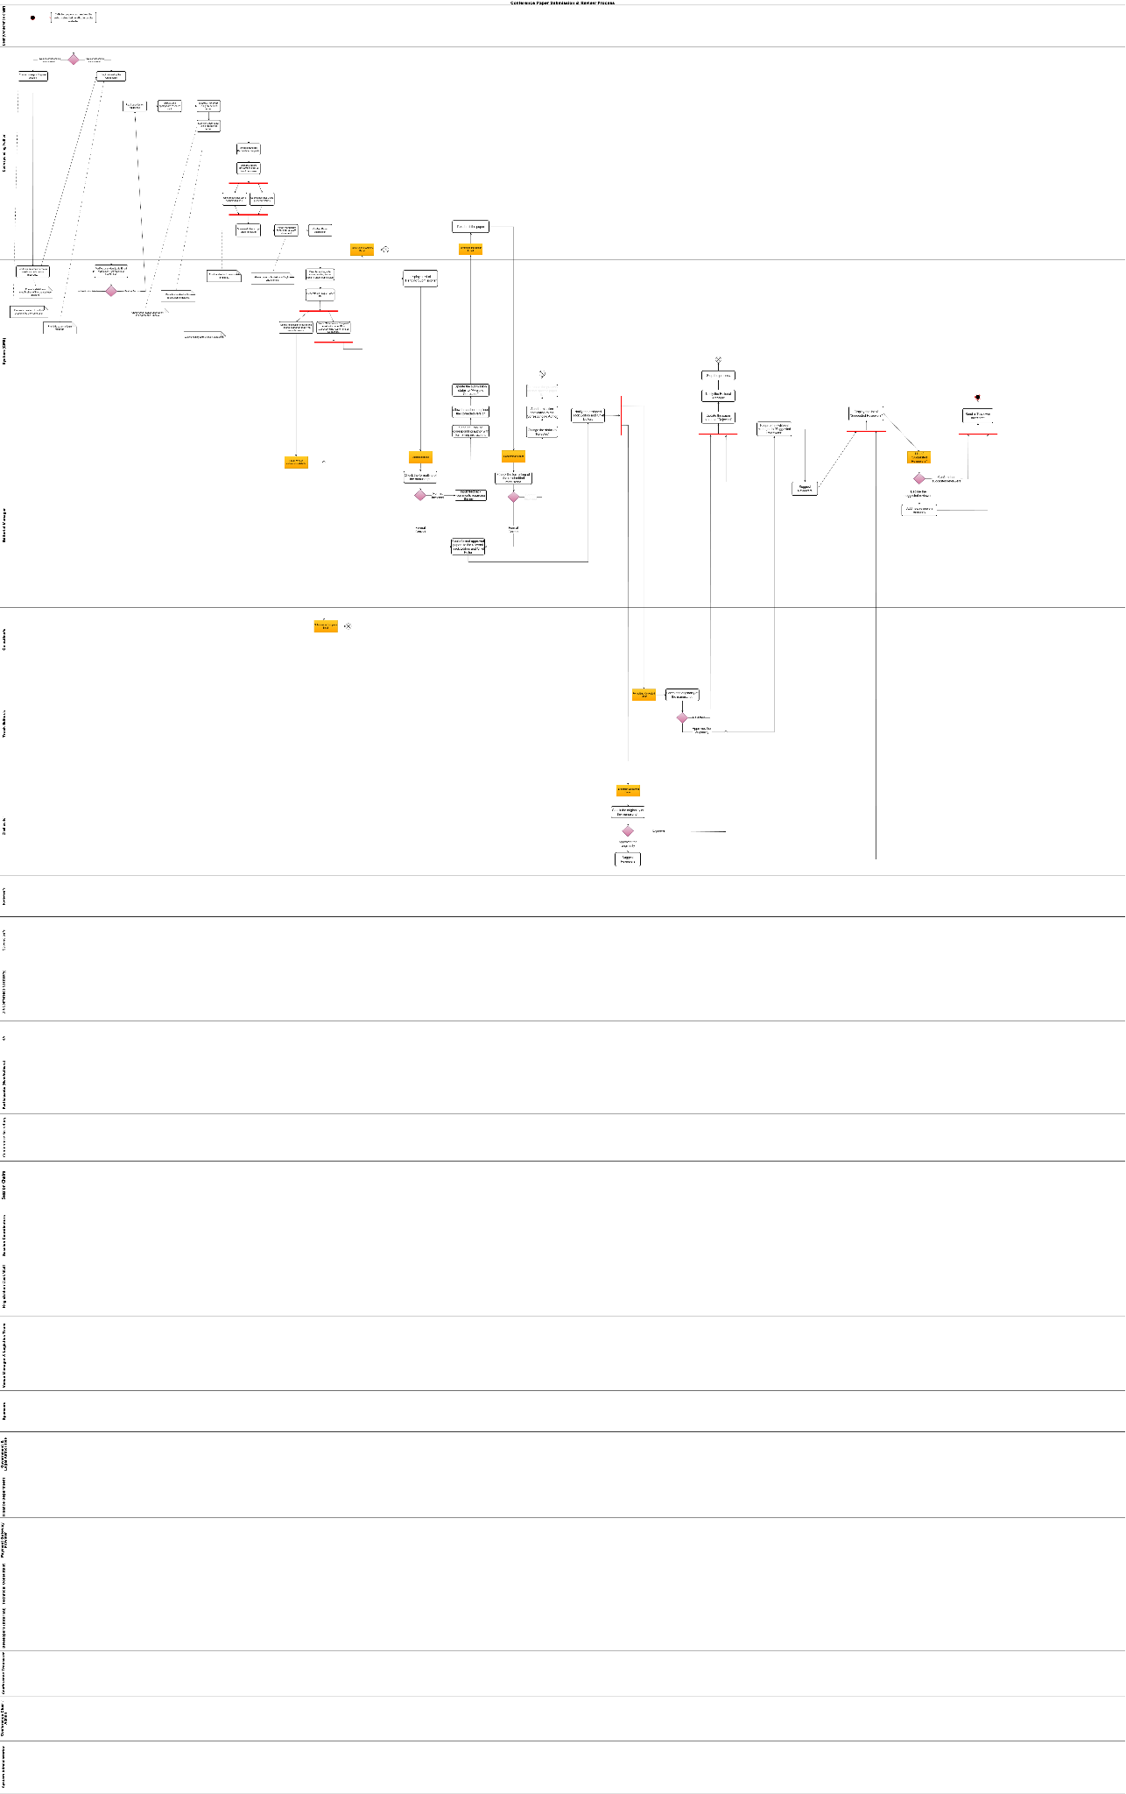
4. Swimlane Activity Diagram

